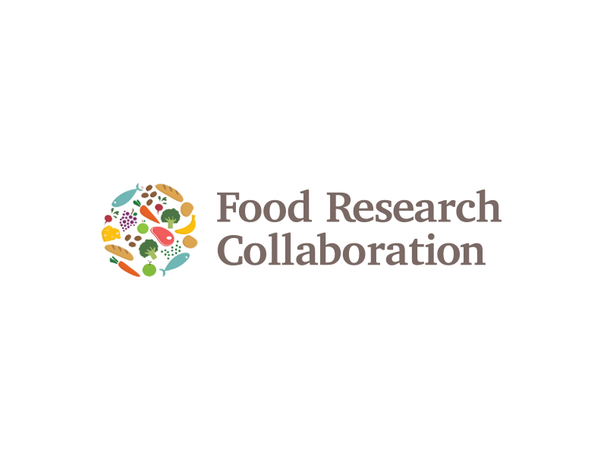

 

PRESS RELEASE

**Embargoed until 00:01 BST on Monday 23 July 2018**

**The clock is ticking for UK food security unless a deal is done, says new report**

Amidst all the political uncertainties, the clock is ticking for UK food security. In the latest *Food Brexit Briefing,* leading food policy specialists urge the Government, food industry and the consuming public to keep focussed on food.

A careless Brexit poses significant risks to food flows into and out of the UK. According to the report, the Government recognises the serious consequences that may ensue because it is making contingency plans to suspend food regulations in the event of a no-deal Brexit.

‘One could argue that this is sensible emergency planning,’ says co-author Prof Tim Lang, ‘but it is also risky. Consumers would rightly wonder who was guaranteeing the safety and quality of the imported food they were buying. Criminals would be alerted to opportunities for food fraud. And the move would send negative signals to the EU, at a delicate time in Brexit negotiations. It could make the UK’s 3rd country status more problematic for exports.’

*Feeding Britain: Food security after Brexit* is by Prof Tim Lang (City), Prof Erik Millstone (Sussex), Tony Lewis (Head of Policy, Chartered Institute of Environmental Health) and Prof Terry Marsden (Cardiff). It takes stock of how food, food security and food regulation are being addressed by HM Government in the Brexit discussions.

The authors welcome the fact that the Chequers Statement of 6 July and subsequent White Paper recognise the importance of agri-food to Brexit. But the documents have major weaknesses. The Government makes a fundamental mistake in proposing close alignment with the EU only for farming and manufacturing, but not for retail or food service. This injects a fault-line into the UK food system between production and service sectors, yet food service is by far the largest source of employment in the entire UK food chain and delivers more gross value added (29%) than the other sectors (agriculture 7%, wholesaling 11%, manufacturing 26%, retailing 27%).

The Government also appears to be ambiguous on the question of migrant workers and how essential they are to the current working of the UK food system.

Finally, too little attention is being paid to the special needs of Wales, Scotland or Northern Ireland, whose economies are highly food-dependent. Prof Terry Marsden says:

'There is a strong need for the joint production of a sustainable food framework which involves the devolved regions of the UK and the regions of England, such that it enhances food security and creates the basis for more healthy food consumption in the UK as a whole.'

*Feeding Britain* also argues that an additional, unnecessary risk is being created by the Food Standards Agency’s decision to press ahead with major reform of UK food safety regulation, at a time when a stable regulatory regime should be in place as the basis of trade and Brexit negotiations. Prof Millstone says:

‘It is vital, in the context of negotiating and enacting Brexit, that the Food Standards Agency, and the UK government more generally, avoid any decisions, proposals or actions, that could adversely affect food safety standards in the UK or the reputation of the UK’s food supply.’

The paper provides a detailed analysis of the significance of the Regulating Our Future (ROF) reforms being undertaken by the Food Standards Agency. Tony Lewis, head of Policy at CIEH, says:

‘The public needs to know that ROF heralds fundamental changes to the way in which food safety, standards and animal feed are to be regulated.”

**ENDS**

**Notes to editors**

The briefing paper, *Feeding Britain* is available for media to read at: [ADD](http://foodresearch.org.uk/publications/food-brexit-northern-ireland/) WEBLINK

It will be published on the Food Research Collaboration website at 00:01 (BST) on Monday 23 July 2018.

**Media enquiries:**

Ross Matthewman (CIEH): [r.matthewman@cieh.org](mailto:r.matthewman@cieh.org)  
**T:**  020 7827 5922| **M:**  07970 949363

Neil Vowles (Sussex) [press@sussex.ac.uk](mailto:press@sussex.ac.uk)

**T**: 01273 873712

Ed Grover (City, University of London): [ed.grover@city.ac.uk](mailto:ed.grover@city.ac.uk);  
**T** 0207 040 3062 **M** 07972 113628

Lindy Sharpe (Food Research Collaboration) [Rosalind.Sharpe@city.ac.uk](mailto:Rosalind.Sharpe@city.ac.uk)

**M**: 07966 162543

**Further Information:**

**Tim Lang** is Professor of Food Policy in the Centre for Food Policy at City, University of London, and special advisor to the Food Research Collaboration. He is Hon Vice-President of CIEH. Email: [t.lang@city.ac.uk](mailto:t.lang@city.ac.uk)

**Erik Millstone** is Emeritus Professor of Science Policy at the University of Sussex’s Science Policy Research Unit. Email: [e.p.millstone@sussex.ac.uk](mailto:e.p.millstone@sussex.ac.uk)

**Tony Lewis** is Head of Policy at the Chartered Institute of Environmental Health based in the London office. He is a qualified Chartered Environmental Health Practitioner. Email:[T.Lewis@cieh.org](mailto:T.Lewis@cieh.org)

**Terry Marsden** is Professor of Environmental Policy and Planning, and Director of the Sustainable Places Research Institute (PLACE), Cardiff University. Email: [MarsdenTK@cardiff.ac.uk](mailto:MarsdenTK@cardiff.ac.uk)

**The Food Research Collaboration** is a UK initiative that brings together academics and civil society organisations to improve the production, sharing and use of evidence-based knowledge to influence and improve UK food policy. It has 600 members and is based at the Centre for Food Policy at City, University of London. This is the sixth of its Food Brexit Briefings.

The **Chartered Institute of Environmental Health** was founded in the 19th century to deliver Victorian public health reforms. It aims to improve public health and wellbeing by supporting its members across many sectors. It provides information, evidence and policy advice to local and national government, regulators, members, stakeholders and the wider environmental health workforce.